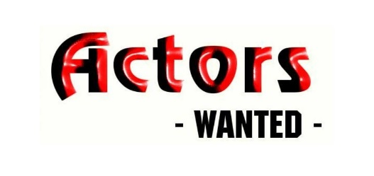

Mastering Acting & Auditioning for Stage & Screen
Ages 11-99 2 hours bi-weekly/3 week session
Instructor: Georgeanne Bruzzese $185

MONDAY April 9, 16, & 23
WEDNESDAY April 11, 18 & 25
All classes 6:45-8:45

During the 2nd edition of this dynamic three-week session, you will learn to sharpen both your acting and auditioning techniques. In this fun and non-judgmental environment, you will have a safe place to develop confidence in yourself and your unique artistic abilities. You will have many opportunities to perform, and to learn from experienced actors, coaches and industry professionals, through improvisation, mock auditions, on-camera training, individualized attention and evaluation and much more. All levels are welcome!

LOCATION: (unless otherwise noted)
Voorhees Middle School
1000 Holly Oak Dr.
Voorhees, NJ 08043
Go to info@voorheestheatre.org for more info and registration form.

*Class will be limited to 10 students.

